How to run Visualization of Atmospheric Ozone Intensity program

This document will provide a user with a clear step by step tutorial on how to run the program – Visualization of Atmospheric Ozone Intensity. Some of the steps will have a before and after picture indicating what each step should achieve for the user if it is followed correctly.

Before you take a look at the steps, make sure that the Matlab software is available, since the program is programmed in Matlab and will only work with this software. If you don’t have the software please download it from the link below:

<https://www.mathworks.com/products/matlab.html>

The project already assumes that the user has all the required data files (o3_surface_20180701000000.nc file and 24Hour folder).

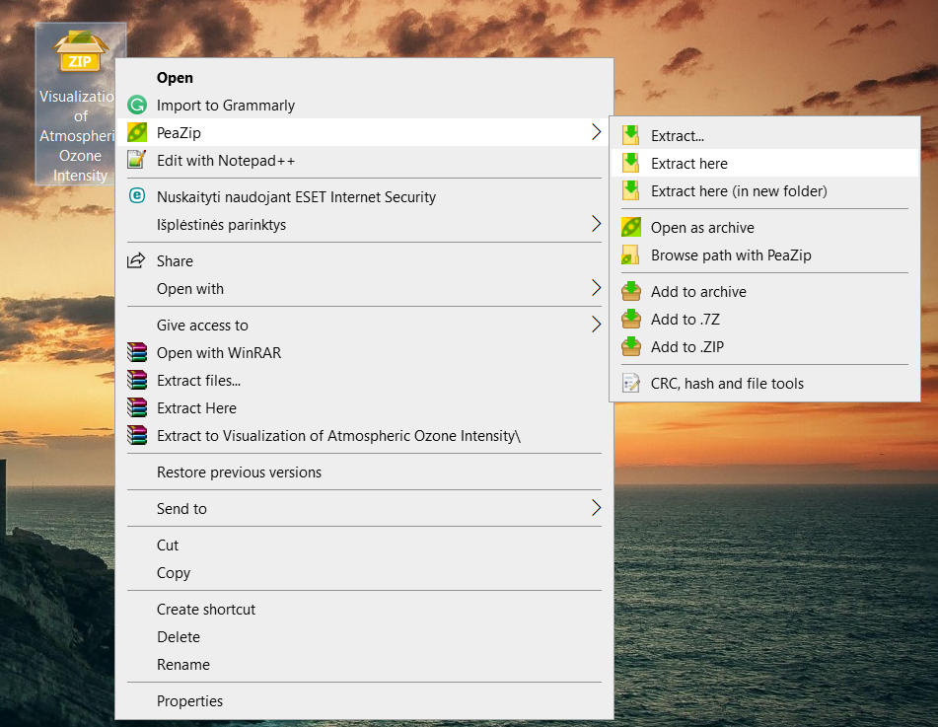

Step 1. Extract the files from the zip file into the location the zip file is currently at or in another location.

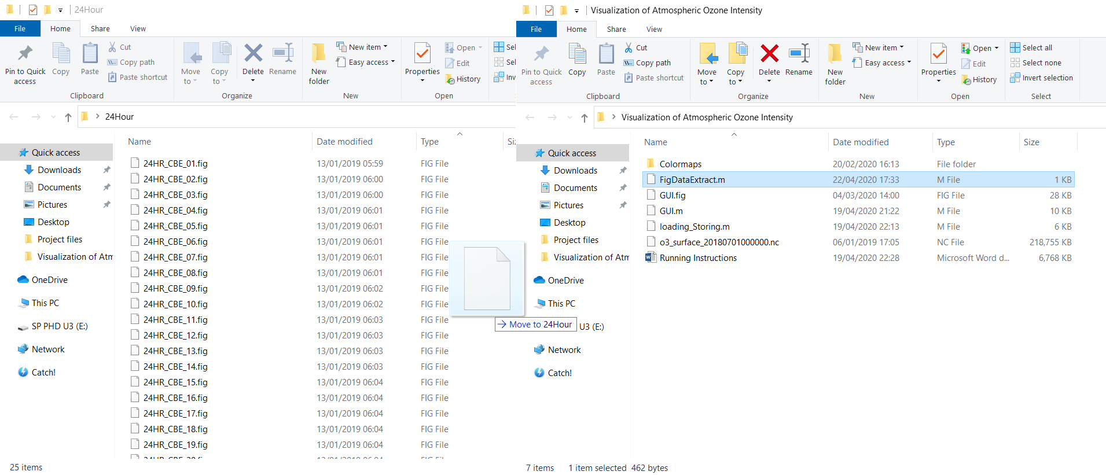

Step 2. When the extraction of the zip file is done, open the folder Visualization of Atmoshperic Ozone Intensity. In the folder, navigate to the file called FigDataExtract.m and put this file in the 24Hour folder which the user should already have. After this is done, close the 24Hour folder and move the folder into the Visualization of Atmospheric Ozone Intensity folder and also move the o3_surface_20180701000000.nc file in it as well then open the 24Hour folder. In it copy the path of the folder and go back to the Visualization of Atmospheric Ozone Intensity folder. The steps can be seen in the pictures below.

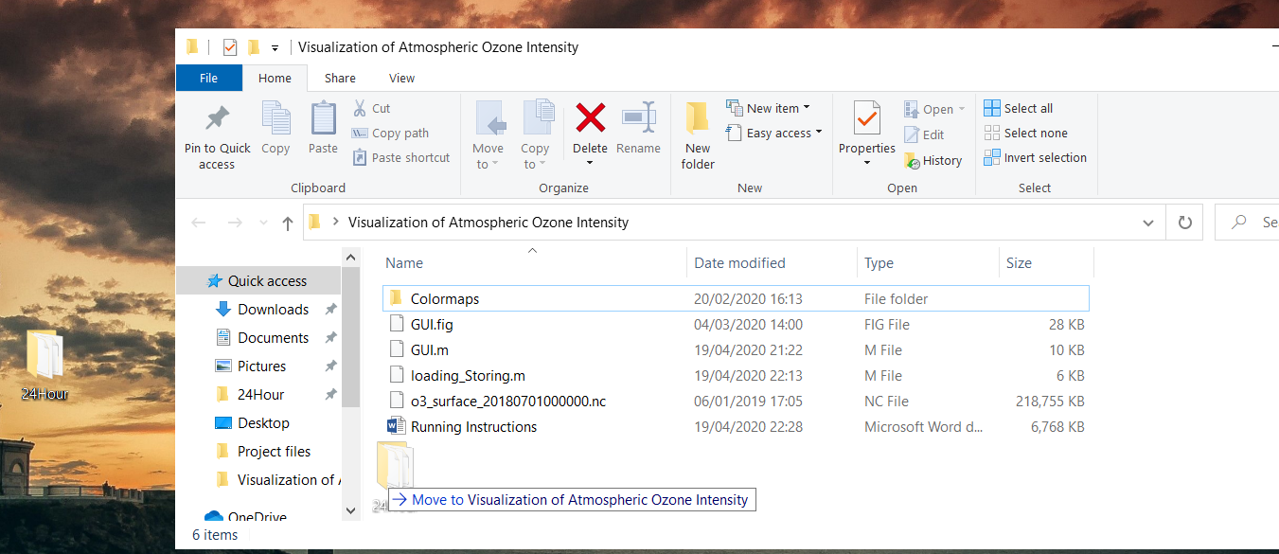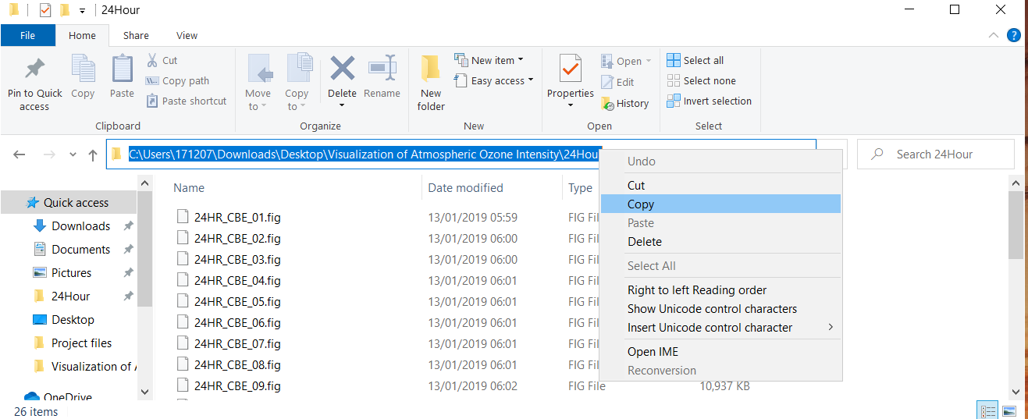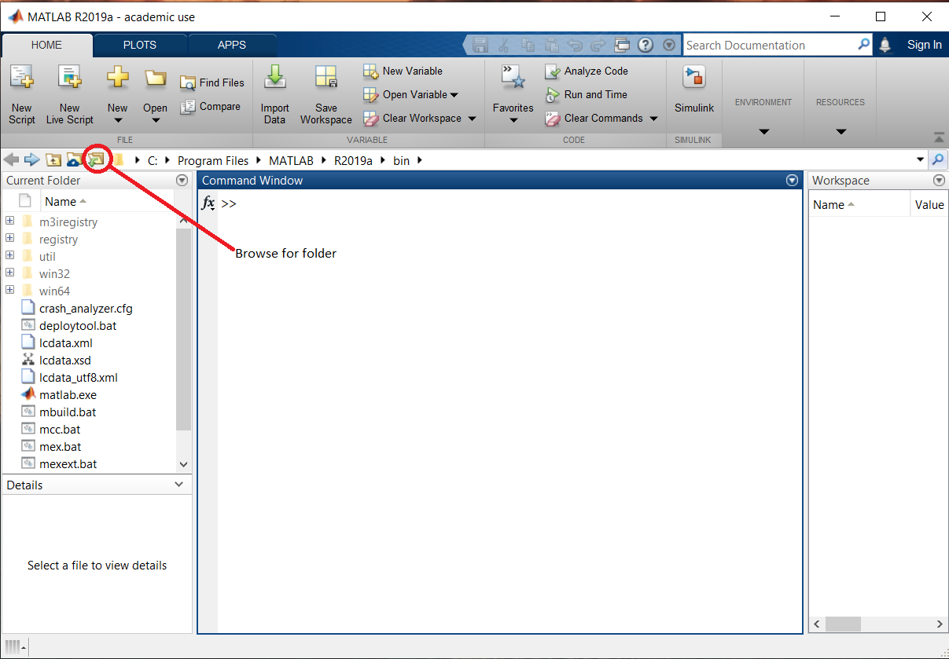

Step 3. Open Matlab software. On the left of the screen locate the "Current folder" tab, above it there will be "Browse for folder" feature. Click on it and select the folder "Visualization of Atmospheric Ozone Intensity".

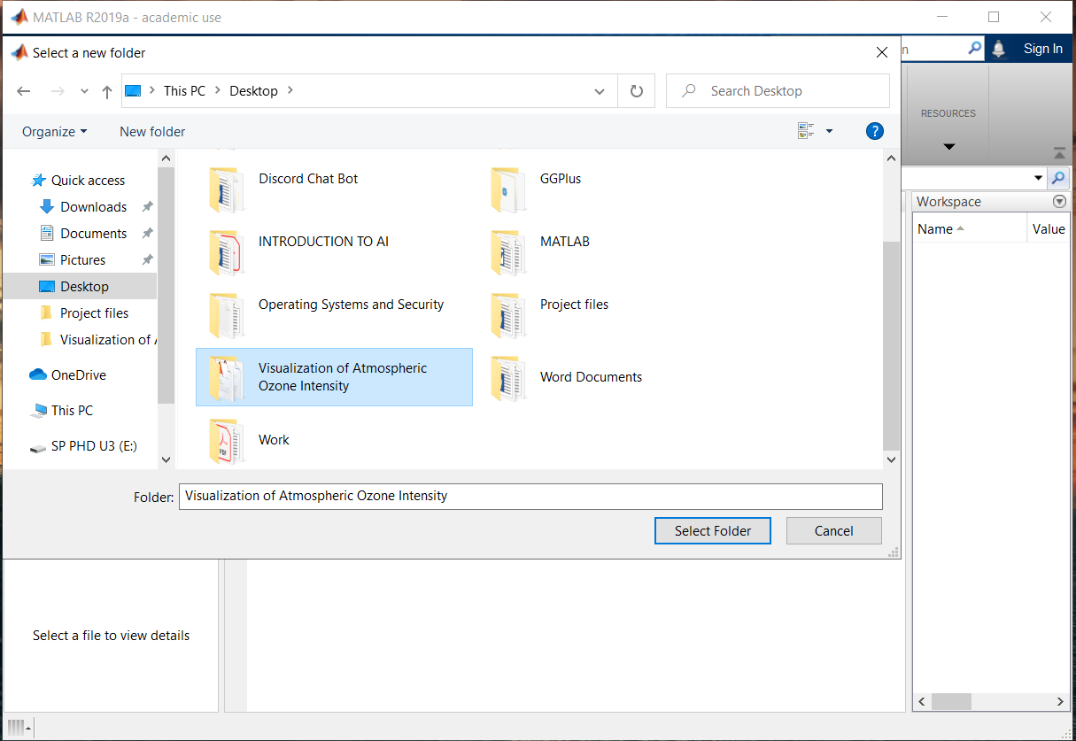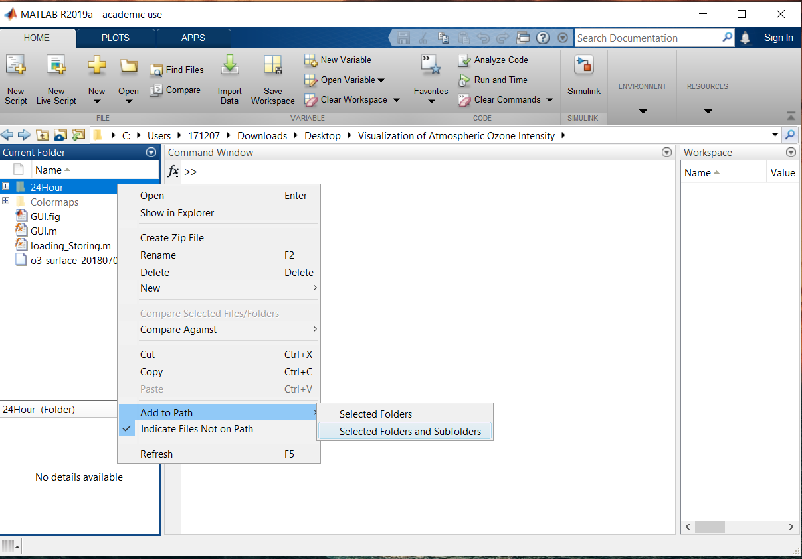

Step 4. When Matlab will open the Visualization of Atmospheric Ozone Intensity folder, the user should notice that the current folder changed. There is now files and folders that belong to the "Visualization of Atmospheric Ozone Intensity" folder. Now navigate to the folder 24Hour and right click on it. Go to “Add to Path” option and select “Selected Folders and Subfolders”, this will add 24Hour folder to the path and if contains any other folders it will include them also. Do the same with folder called “Colormaps”. After these folders are added to path the grey color from them should disappear as in the picture below.

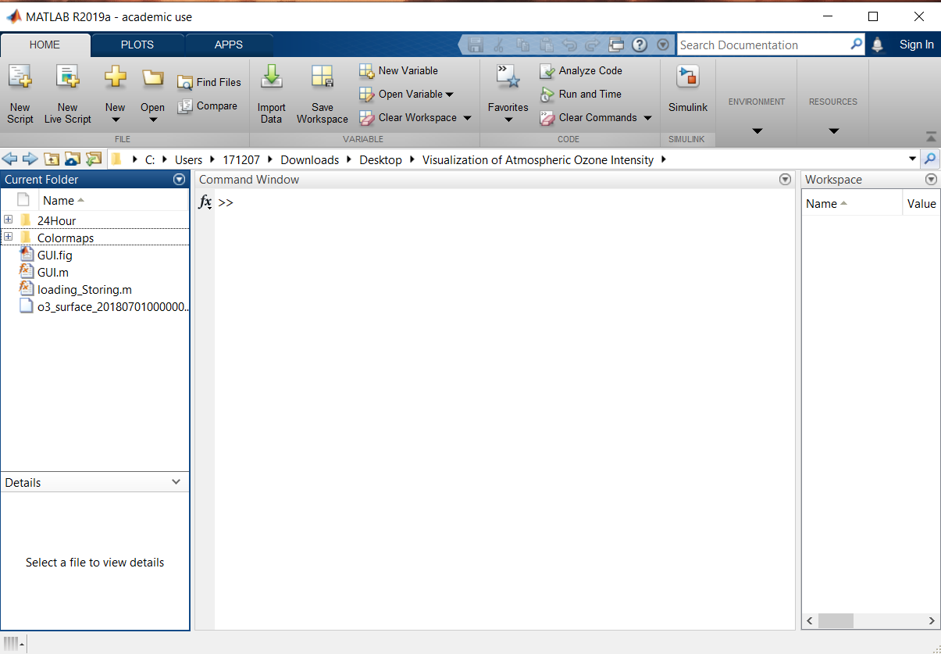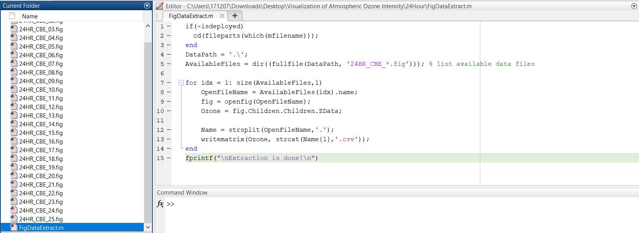

Step 5. After both the 24Hour and Colourmaps folders are included in the path of Matlab, navigate to 24Hour folder and inside of it open the file FigDataExtract.m which should be at the bottom of the folder. In the file the user can see a Matlab code about which user do not need to worry about. Click on the “Run” button at the top of the editor tab and wait for the program to execute. Multiple windows will appear while the program is being run and new files will appear in the document 24Hour. Do not close any of the windows until in the command window there is a message presented “Extraction is done!”. After this message is presented, the user can start closing down the popped up windows, every single of them. Just be sure not to close the Matlab window itself.

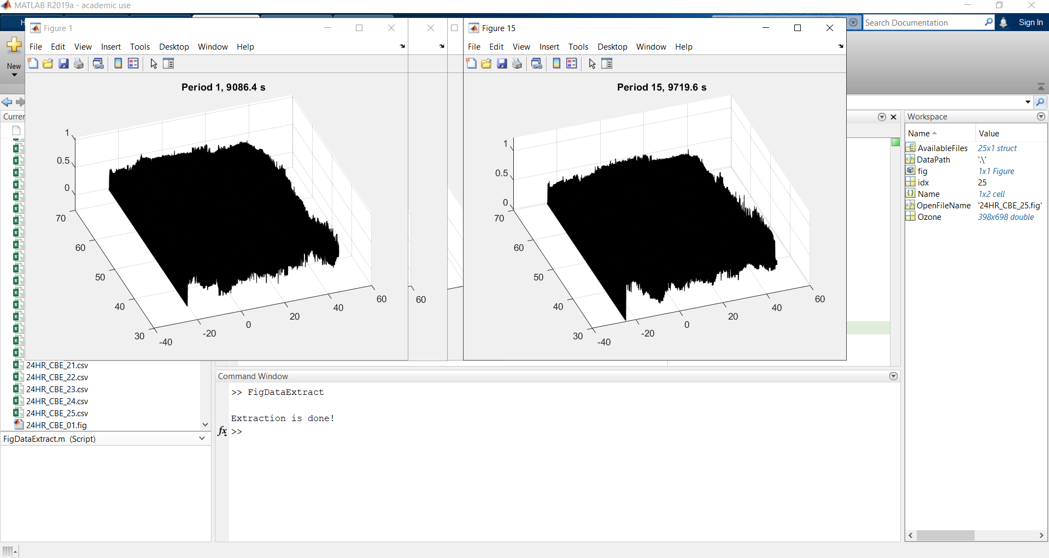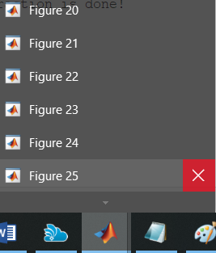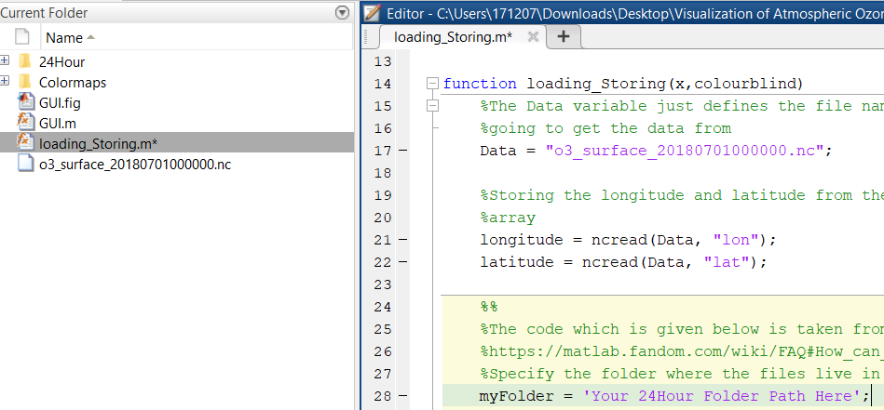

Step 6. Go back to the Visualization of Atmospheric Ozone Intensity folder and open loading_Storing.m file in Matlab and go down to line 28, line position can be seen on the left of the code. On line 28 there is only one thing that needs to be changed - variable "myFolder". Change this variables value to be the path of 24Hour folder that you have copied and put it in between ‘ ’. Make sure it is put in between ‘ ’ and make sure that it ends with 24Hour name. The full variable should look like in the second picture after this.

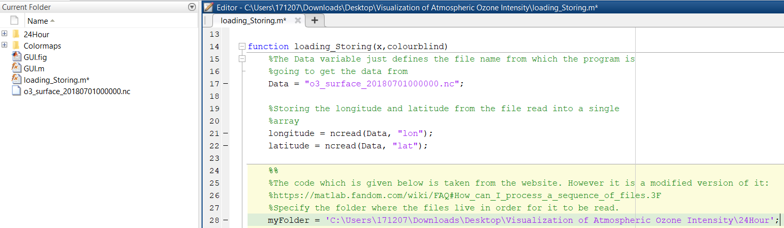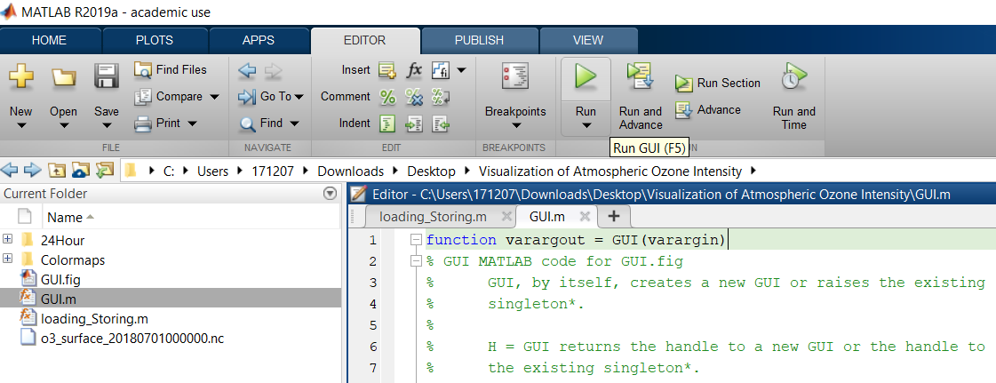

Step 7. When all of the above steps have been achieved, open file GUI.m (NOTE: Not GUI.fig!). Navigate to the EDITOR which is located above all of the code and files. Click on the "Run" button while being in the GUI.m. A new window with graphical user interface should appear and the map will start loading up. Give it a bit for it to load up and when the map fully loads (The colors of the map are visible), it means that you can start using the functionalities of the GUI.

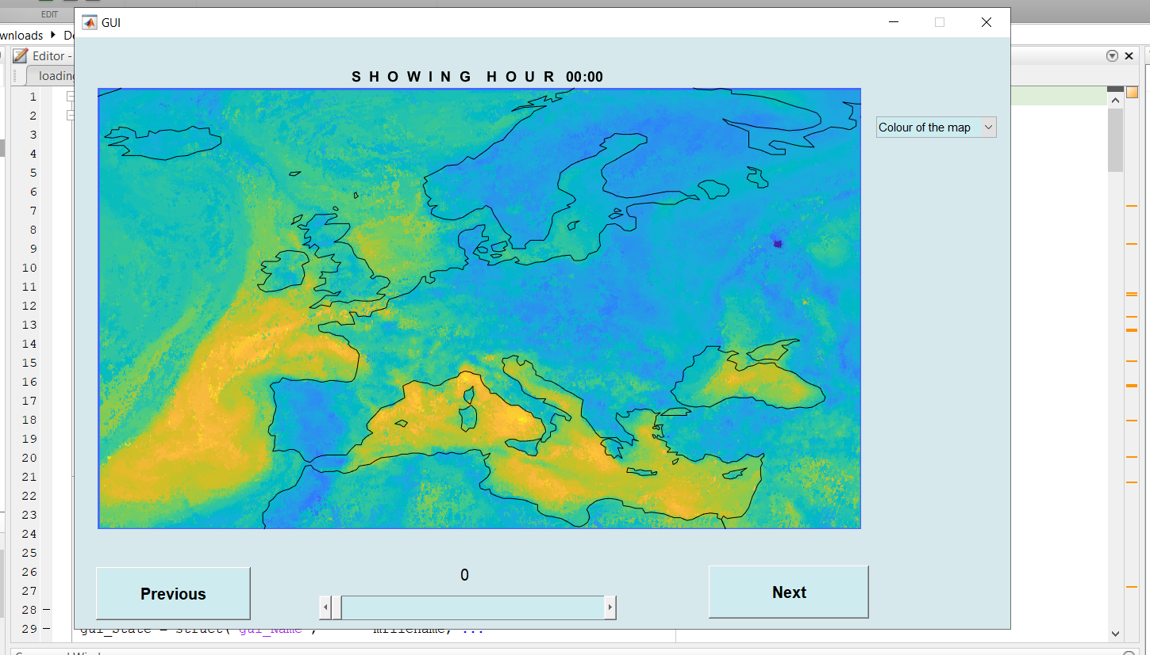

This is the end of the document. By this moment the program should work smoothly and everything should be working correctly. Thank you for taking your time and following these steps.